Food Delivery Job in India: Salary, Hours, Problems aur Future Growth: Sab Kuch Ek Jagah
By Vahan · Updated: 30 May 2026 | Published: 30 May 2026
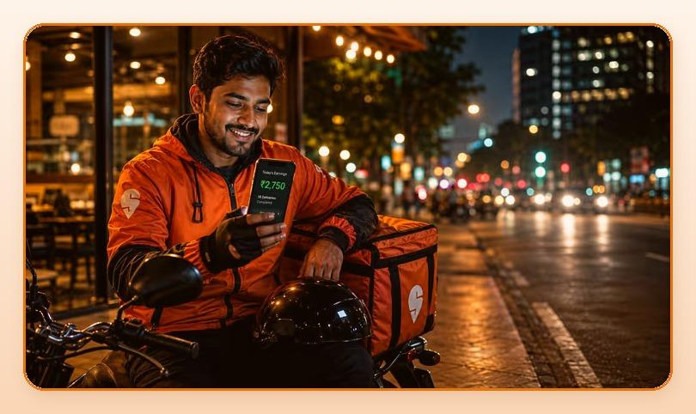
Summarize with ChatGPT · Gemini · Claude · Perplexity (tool icons in design)

Key Takeaways
- Average monthly income: Rs.25,000 - Rs.35,000. Full-time kaam karein to Rs.30,000 - Rs.45,000+ easily.
- India ka food delivery market 2024 mein approximately $10 billion tha, aur 2030 tak $30+ billion hone ki expectation hai.
- Sirf chahiye: ek bike, ek smartphone, aur kaam karne ki aadat. Bas.
- Haan, challenges hain, lekin sahi approach se inhe manage kiya ja sakta hai.

Table of Contents
- Delivery Job Kya Hai? Ek Quick Introduction
- Delivery Job Mein Salary Kitni Milti Hai? Realistic Numbers
- Daily Kitne Ghante Kaam Karna Padta Hai? Flexible Working Hours
- Peak Hours: Earning Maximise Kaise Karein?
- Delivery Job Ke Liye Sahi Umar Kya Hai?
- Food Delivery Job Mein Real Problems: Jo Koi Nahi Batata
- Food Delivery Job Ka Future India Mein: Scope Aur Career Growth
- Conclusion: Kya Food Delivery Job Aapke Liye Sahi Hai?

Aaj ke zamane mein food delivery job India ke sabse tezi se badhne wale gig economy jobs mein se ek ban chuki hai. Zomato, Swiggy, Blinkit, Zepto, aur Amazon Fresh jaise platforms ne lakho logon ko stable income diya hai. Khaaskar un logon ko jo flexible working hours mein kaam karna chahte hain, ya traditional 9-to-5 se alag kuch dhundh rahe hain.
Agar aap soch rahe hain ki delivery partner job kaisi hoti hai, kitni salary milti hai, kya problems face karni padti hain, aur is field mein future growth kya hai, to ye guide sirf aapke liye likhi gayi hai.

Delivery Job Kya Hai? Ek Quick Introduction
Delivery partner job ek gig economy role hai jisme aap Swiggy, Zomato, Blinkit ya Zepto jaise apps ke liye customers ke ghar tak food, grocery ya parcel deliver karte hain. Ye India ke fastest-growing part-time aur full-time jobs mein se ek hai. Iske liye koi bhi degree ya experience ki zaroorat nahi hoti.
Sirf chahiye: ek bike, ek smartphone, aur kaam karne ki aadat. Bas.
Vahan.co ek trusted platform hai jo delivery job seekers ko India ke top companies jaise Zomato, Swiggy, Blinkit, Zepto, Porter, Rapido, Flipkart, Shadowfax aur Uber ke saath directly connect karta hai. Bilkul free mein, 1-click WhatsApp application se.

Delivery Job Mein Salary Kitni Milti Hai? Realistic Numbers
Ye ek sabse common sawaal hai jo har delivery job seeker poochta hai: 'Delivery boy ki salary kitni hoti hai India mein?' To seedha jawaab yahan hai:
- Average monthly income: Rs.25,000 - Rs.35,000
- Full-time kaam karein to: Rs.30,000 - Rs.45,000+ easily
- Overtime aur peak hours mein: Rs.40,000 - Rs.50,000 tak possible
- Swiggy/Zomato per-delivery rate: approx Rs.20 - Rs.50 per delivery
- Ek achha delivery partner din mein 20-35 orders complete kar sakta hai
Earning depend karti hain city, platform, working hours, aur incentives par. Metro cities (Mumbai, Delhi, Bengaluru, Hyderabad) mein earnings comparatively zyada hoti hain. Plus, top performers ko monthly bonuses bhi milte hain. Consistent kaam aur acha rating rakhna zaroori hai.
Pro Tip: Ratings acha rakhne se platform automatically zyada orders deta hai, matlab zyada earning, automatically.

Delivery Job Chahiye? Abhi Apply Karein.
Get Started

Daily Kitne Ghante Kaam Karna Padta Hai? Flexible Working Hours
Food delivery job ki sabse badi appeal hai uski flexibility. Koi fixed shift nahi, koi boss nahi. Aap khud apna schedule decide karte hain. Ye structure most part-time job seekers ke liye perfect hai:
- Part-Time (4-6 hours/day): Rs.8,000 - Rs.15,000/month
- Full-Time (8-10 hours/day): Rs.20,000 - Rs.30,000/month
- Overtime (12+ hours/day): Rs.35,000 - Rs.50,000+/month
Healthy balance: 8-9 ghante kaam karo, proper breaks lo, hydrated raho. Weekend aur festival seasons (Diwali, New Year, Independence Day) mein orders boom karte hain. Ye highest earning opportunities hote hain.

Peak Hours: Earning Maximise Kaise Karein?
Delivery job mein timing sab kuch hai. Sahi waqt par niklo, orders ki barsaat ho jaegi. India ke top peak hours:
- Subah Nashta: 8:00 AM - 10:30 AM (chai, poha, office workers ke orders)
- Lunch Rush: 12:00 PM - 2:30 PM (sabse zyada orders is time aate hain)
- Evening Snacks: 5:00 PM - 7:00 PM (chai, samosa, fast food)
- Dinner Peak: 7:30 PM - 10:30 PM (family dinners, late night cravings)
- Rain aur Weekends: Har time peak, orders 2x-3x badh jaate hain!
Expert Strategy: Lunch aur dinner slots mein milkar 5-6 ghante kaam karo. Is approach se daily Rs.700 - Rs.1,200 easily earn ho sakti hai. Baarish mein delivery mushkil hoti hai, lekin earning double hoti hai.

Delivery Job Ke Liye Sahi Umar Kya Hai?
Officially minimum age hai 18 saal. Ye job 18 se 35 saal ke logon ke liye sabse suitable hai, kyunki:
- Physical stamina zyada hoti hai
- Naye areas quickly seekh sakte hain (Google Maps navigation fast ho jaata hai)
- Financial independence chahiye, college fees, family support, ya startup fund ke liye
- Long-term career explore karne ka waqt hota hai
Students ke liye toh ye ek golden opportunity hai: Morning college, evening delivery, aur month end pe solid earning. 35+ ke baad bhi ye job possible hai, lekin long shifts physically taxing ho sakte hain. 10th pass? Bike hai? Aap eligible hain. Bas itna kaafi hai vahan.co par apply karne ke liye.

Food Delivery Job Mein Real Problems: Jo Koi Nahi Batata
Ab baat karte hain uss cheez ki jo aksar koi nahi batata. Agar aap is field mein aana chahte hain, in challenges ke baare mein pehle se jaanna zaroori hai:
1. Weather aur Physical Fatigue
Garmi ho, sardi ho, ya baarish, delivery toh karni hi hai. Proper gear (raincoat, sun protection) mein invest karna zaroori hai. Long-term mein ye aapko mushkilon se bachata hai.
2. Traffic aur Road Safety
India ke roads pe traffic ek nightmare hai. Delivery partners pe time pressure hota hai. Lekin hamesha safe driving priority honi chahiye, chahe thodi delay ho. Ek accident poori mehnat barbad kar sakta hai.
3. Customer Complaints aur Ratings
Kabhi food spill ho jaata hai, order late hota hai, ya restaurant ki galti se item missing hoti hai, blame delivery partner ko milta hai. Polite rehna aur platform ke saath clearly communicate karna best solution hai.
4. Bike Maintenance aur Petrol Costs
Delivery partners ko apni bike khud maintain karni hoti hai. Monthly Rs.2,000 - Rs.4,000 maintenance mein lag sakta hai. Iska budget pehle se banao, ye directly aapki net earning affect karta hai.
5. Income Kabhi Kabhi Unpredictable
Kuch din orders bahut zyada, kuch din bilkul nahi. Emergency fund rakhna zaroori hai. Consistent working hours rakhoge toh income predictable ho jaati hai.
6. Health aur Insurance
Gig workers ko typically company health insurance nahi milta. Ek affordable health insurance plan zaroori hai. Kuch platforms (Swiggy, Zomato, Blinkit) ab basic accident coverage dene lage hain, join karne se pehle check karein. In Sabke Baad Bhi: Delivery Job India Ka Best Flexible Income Option Hai.

Food Delivery Job Ka Future India Mein: Scope Aur Career Growth
India ka food delivery market 2024 mein approximately $10 billion tha, aur 2030 tak $30+ billion hone ki expectation hai. Matlab? Is industry mein opportunities sirf badhne wali hain aur aap iske ground floor par hain.
Career Growth ke Raste:
- Delivery Executive se Team Leader/Supervisor: Rs.35,000 - Rs.50,000/month
- Zonal Manager ya Operations Manager: Rs.50,000 - Rs.80,000/month
- Franchise ya Dark Kitchen start karna, khud ka business
- Training aur Onboarding Executive banna
- Logistics startups mein full-time employment
Quick Commerce (Blinkit, Zepto, Swiggy Instamart) ke rise ne delivery jobs ki demand aur bhi badha di hai. Ab sirf food nahi, groceries, medicines, aur electronics bhi deliver ho rahe hain. Ye ek growing ecosystem hai, sirf ek job nahi.
Jo log consistently achha kaam karte hain, unhe platforms khud promote karte hain. Delivery job sirf ek starting point hai. Agar mehnat aur commitment ho, to is industry mein ek solid career banaya ja sakta hai.

Conclusion: Kya Food Delivery Job Aapke Liye Sahi Hai?
Food delivery job India mein ek fast-growing, flexible, aur solid income wala option hai. Haan, challenges hain, lekin sahi approach se inhe manage kiya ja sakta hai.
Agar aap:
- Flexible hours mein kaam karna chahte hain
- Turant income start karna chahte hain
- Part-time ya full-time dono options explore karna chahte hain
- Kisi bhi Indian city mein stable gig income chahte hain
...to food delivery job aapke liye ek excellent opportunity hai. Sahi platform chunein, peak hours mein kaam karein, apni bike ka dhyan rakhein, aur consistently accha service dein. Success aapki hi hai.
Aaj Hi Delivery Partner Bano: vahan.co par Free Registration Karo

Delivery Job Chahiye? Abhi Apply Karein: vahan.co/jobs

